Packing List

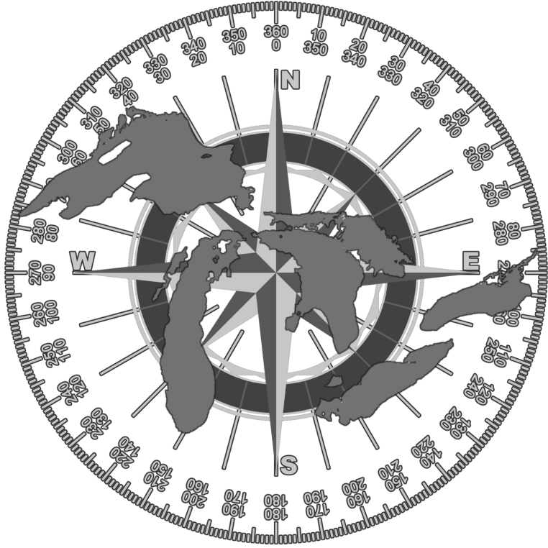
Campsite
- Tent
- Sleeping Bag(s)
- Blanket
- Air Mattress or Sleeping Pad
- Tarps
- Pillow
- Ropes
- Hatchet
- Hand Saw
- Bungee Cords
- Plastic Ties
- Container for garbage

Cooking
- Multiple Lighters
- Can Openers
- Kettle
- Bowls
- Plates
- Cutlery
- Oven Mitts
- Small Grill
- Pot
- Water

www.sleepingunderthestars.ca

Travel
- Portable power banks for phone
- Phone Cords
- Compass
- GPS
- Map Book
- Binoculars

Hygiene
- Soap
- Toilet Paper
- Toothpaste
- Sun Block
- Insect repellant
- Hand Sanitizer
- Contacts and/or Glasses
- Small shovel
- Tampons or Pads.
- Medications Prescription/Fun
- Nail Clippers
- Q-tips

Boating
- Kayak/canoe
- Roof racks
- Paddle(s)
- Life jacket
- Water safety kit

First Aid Kit
- Tweezers
- Nonstick sterile gauze pads
- Assorted Band-Aids
- Rolled bandage
- Cleansing Wipes
- Polysporin Triple Antibiotic
- Anti-histamine
- Sticky Tape
- Anti-inflammatory
- Pain killers
- Hydrocortisone

Clothing
- Multiple Sweatsuits
- Raincoat
- Towels
- Hat with a Brim
- Shoes
- Socks
- Underwear items
- Short-sleeved shirts
- Long-sleeved shirts and sweaters
- Shorts/bathing suits
- Pants
- Toque
www.sleepingunderthestars.ca

Extras
- Sudokus, Crosswords and Find a word
- Books and magazines
- Paper and art supplies
- Solar Charged Patio Light
- Power Bar (for multiple charges in car)
- Portable water filter
- Emergency Candles
